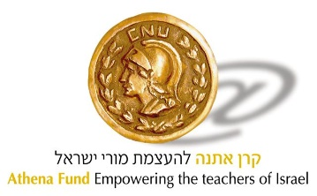

**How do you donate through PEF?**

o The Athena Fund is approved for donations through PEF. If the donation is for a specific project, this must be stated in the letter accompanying the donation.

1. Sending a donation:

o the donor must send a check for the donation amount to:

PEF Israel Endowment Funds, Inc.

o in the memo of the check or in an accompanying letter it must be stated:

♣ Name of the organization in Israel: Athena Fund.

♣ The goal: "Establishing an imagination laboratory in [specific location]".

♣ Contact details if further clarification is required.

2. Address for sending the donation:

PEF Israel Endowment Funds, Inc.

630 Third Ave, Ste 1501

New York, NY 10017

USA

1. Additional ways:

o the donation can be transferred via bank transfer. PEF must be contacted in advance for account information.

2. Receipt of receipt:

o After receiving the donation, PEF issues a receipt recognized for US tax purposes. The receipt will be sent to the donor's address.

**Steps to transfer bank contribution to PEF**

1. Contacting PEF in advance:

o Before making the bank transfer, it is recommended to send an email to PEF to inform them of the planned donation and request their account details.

o Email address for contact: [info@pefisrael.org](mailto:info@pefisrael.org).

2. Sending the donation details:

o the following details must be included in the email:

♣ Name of the donor.

♣ The amount of the donation.

♣ The specific purpose of the donation (for example: "Athena Foundation - establishment of an imagination laboratory in place X").

♣ Receipt delivery address.

3. Receiving bank account details:

o PEF will reply by email with their bank account details for bank transfers.

4. Performing the transfer:

o the bank transfer must be made according to the instructions you received from PEF.

o Be sure to indicate in the description of the transfer the purpose of the donation and the name of the beneficiary organization (for example: "Athena Fund").

5. Sending transfer confirmation:

o After making the transfer, the confirmation from the bank about making the transfer must be sent to PEF's email, so that they know to associate the donation with the requested institution.

6. Receipt of receipt:

o PEF will issue a recognized receipt for US tax purposes and send it to the address provided by the donor.

**Important details:**

• Processing Time: Bank transfers may take several days to be received and processed by PEF.

• Bank fees: Make sure the bank covers all the fees required for an international transfer, so that the full amount reaches the PEF.